# Adding indexes to LIMS

There are two workable ways to add indexes, see method 1 and 2 below. The only difference is the amount of setup work vs. the amount of clicking/typing per index.

**See also the bottom section, which should be done after either of the procedures.**

First, some general concerns.

## Identifying correct index to add

When faced with an unknown set of indexes, it is usually good to try to find a reference for the indexes, and add all the indexes in that reference. If they are custom indexes without a reference, they may be added directly as they appear in the submission.

It may be useful to check out the existing reagent categories and reagent types in the Operations UI, to make sure the indexes have not already been added.

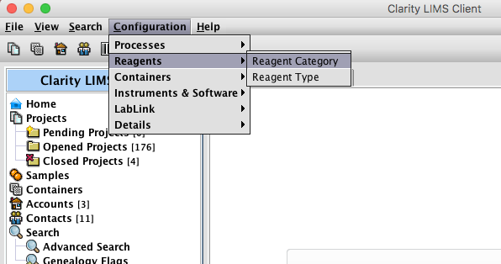

Commercial kits typically have documentation online to show the index sequences. If provided, use sequence for “Sample sheet”, “Sample Sheet on HiSeq 2500/MiSeq”. If they provide sequence for sample sheet on NextSeq or HiSeq 4000, and it’s a dual index, the second index must be reverse complemented before adding it. The Clarity system internally stores indexes in the way they are read on HiSeq 2500, and adapts them as necessary when generating sample sheets.

Watch out: Many kits use identical sequences to Illumina TruSeq or Nextera. These should not be added to LIMS, as that will only confuse the scripts, causing “multiple reagent categories match” errors. If the documentation indicates that the indexes are identical to TruSeq or Nextera sequences, but they will not import in LIMS, check if they have been provided in the submission as reverse-complement or swapped the first and second index.

## Index name requirements

When importing indexes you must give each one a name. If the indexes have names which are somewhat particular to the kit, e.g. AD001, D701-D501, those can be used. If they are called something generic like Index 01..Index 96, you can prefix a short group name, “NEBNext-Index 01”. The name must also contain the complete index sequence, otherwise the script won’t be able to look up the sequence. The Excel based index generator (method 1) adds this automatically, but it must be done manually if using the “Few indexes” method.

Custom indexes, which are to be used once or a few times, can be given a name such as “Custom index 4 Test1 (AAAAAA)”, where 4 is the group of custom indexes and Test1 is a tag given to that particular index. Instead of Test1, it could be just 001.

## METHOD 1: Many indexes – Using the config slicer (>~ 10 indexes)

This requires a user with sudo access on the relevant LIMS server.

First, the Excel based XML generator can be used to generate an XML file for import into LIMS. There are two generator spreadsheets, one for single index and one for dual index. They are available at:

Dual: <https://github.com/nsc-norway/system/blob/master/Dual_Indexing_ReagentType_Config_Slicer_XML_Generator-B.xlsx?raw=true>

Single: <https://github.com/nsc-norway/system/blob/master/Single_Indexing_ReagentType_Config_Slicer_XML_Generator-B-1.xlsx?raw=true>

(Newer versions may be found in Zendesk. Note that there exists other versions which don’t add the sequence to the name, which should be avoided.)

Both files support adding up to 96 indexes at a time, but the dual index spreadsheet can do only 12 index1 sequences and 8 index2 sequences (Using fewer than 12x8 may require some complex editing). *The single index spreadsheet can also be used to import dual indexes, if you have all of the combinations in a column already*, with index1 and index2 separated by hyphen*.*

Input the names and sequences into the first sheet of the spreadsheet. You don’t need to add the sequence to the name, this will be done automatically (see “example reagent name”). **Make sure to also enter a name for the reagent category near the top**. The name can be the name of the kit, or if using a custom index, Custom Indexes *N* (*Project name*). Check in the operations UI first that there is not already one reagent category with the given name.

The output is on the second sheet, in XML format, and the entire sheet can be copy-pasted.

If importing fewer than 96 indexes, empty elements must be removed from near the bottom of the XML. The data may be copied to an empty text editor. Keep the end tags,

|  |
| --- |
| **</ReagentTypes>** |
| </config> |

Then remove the rtp:reagent-type blocks which have name=”0 {0}” (or similar). The blocks come in the same order as the first sheet, so the empty ones can be found at the bottom (at least for the single index spreadsheet).

To import the XML data into LIMS, log on to the LIMS server, change to the glsjboss user and go to the config-slicer directory:

ssh xxxx-lims.sequencing.uio.no

sudo -s -u glsjboss

cd /opt/gls/clarity/tools/config-slicer

By far the easiest is to copy-paste the XML data into the terminal, but it may be corrupted depending on the terminal.

cat > 20170927-test.xml

(Change the filename 20170927-test.xml to something descriptive of the indexes, or even just “indexes”). Paste the data into the terminal and end with enter, then Ctrl-D.

A safer alternative is to save it to a file and transfer with scp, but you will have to deal with permissions. E.g. transfer it to /tmp on the LIMS server as your user, then set it to readable by all (chmod a+r /tmp/datafile.xml), then change to the glsjboss user, then copy it into the config-slicer directory.

Finally import it using config slicer. There is a wrapper script cs.sh, which calls config slicer with the correct URL, username and password. The command is then just:

./cs.sh -o import -k 20170927-test.xml

Now it is finished, proceed to the last section in this document.

## METHOD 2: Few indexes – Using Ops. UI only (up to about 10 indexes)

Log on to the ops. UI and open the Reagent Category screen (as shown in the second section).

Click on Add, and enter a unique name for this group of indexes (Reagent Category). The format of the name is arbitrary. For a single project, it can be called Custom Indexes *N* (*Project name*). See other examples.

Then go to the Reagent Type screen, located in the menu on the left just below Reagent Category. Add all the indexes. For each index, do this:

* Choose Add
* Select Reagent Category that was just created
* Select Special Type: Index
* Enter the index sequence. If it’s a dual index, use hyphen (-) to separate the indexes.
* Also enter the index name. The sequence should be added in parentheses at the end of the name, e.g. AD001 (ATCACG). Again, for dual indexes, separate them with hyphen.

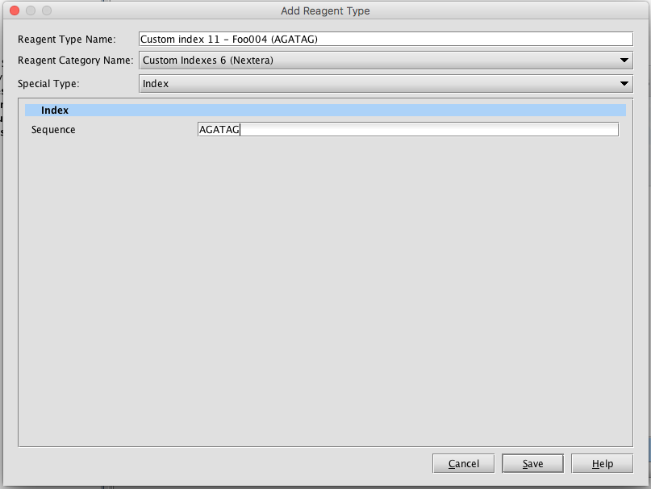

(Continue to next index, until finished)

Then proceed to the next section.

## Adding the index categories to the Project Evaluation page

The indexes are already available in the Auto-detect script, but it may be useful to be able to pick them on the Project Evaluation screen. This may not be necessary for single-use custom indexes.

Open the Ops. UI and go to Configuration 🡪 Details 🡪 Fields (see figure below). Open the field called “Index category (prepared libraries)”, go to the Preset Values tab, and Add a new entry with exactly the name given in Reagent Category.

